PAPER TITLE

A. Author^{1,2}, B. Author², C. Author³, …(List of authors in 10 point, centred and bold: the presenting author underlined)

¹ Author's affiliation, City, Country (10 point, centred and in italics)
² Author's affiliation, City, Country
³ Author's affiliation, City, Country
Presenting author e-mail address: in 10 point, centred and in italics

Keywords: experiment, data, result
The first author should specify the speaker, highlight the underscore. Contact phone and e-mail should be indicated only for the speaker.
The abstracts should reflect the relevance of the work, set the goal and indicate the practical importance of the work, as well as a short reference list of the main sources used (up to 5 titles) and keywords. All references should numbered ([1] or [1-3]) and appear at the end of the abstract in the same order as used in the text. The font should be the same as the main body of the text but with 10pt size.
The abstracts are presented in the text editor Word (RTF format). Abstract should not exceed two pages in length. The dimension of the paper is A5 size paper: 148mm x 210mm. Margins should be 1.75 cm on all sides, and the text should be written in 11 point Times New Roman (and Symbol, if necessary) with single spaced lines. All paragraphs should be justified and indented by 5 mm. For writing formulas use Microsoft Equation:
(1)
A couple of Figures/Tables may be included to the abstract (no more one figure and one table). Figures should be centred. The figures must be located into the hidden table. Figure captions, in 10pt, should be positioned in centre below the figure. Table captions, also in 10pt, should be positioned centred above the tables. The example of the table in the text is presented below. For any figure or table in the text there should be a link.
Incorrect abstracts will not be included in the book of abstracts of the symposium.
Table 1. The intensity of laser radiation corresponding to the threshold for fragmentation of gold nanoparticles
Laser radiation wavelength | Nano-particle radius | Pulse duration | Experimental threshold of fragmentation | Calculated threshold of fragmentation (melting)
400 nm | 30 nm | 150 fs | (7.3±1.5) mJ/cm² | 7.6 mJ/cm²
532 nm | 30 nm | 150 fs | (3.6±0.5) mJ/cm² | 4.2 mJ/cm²

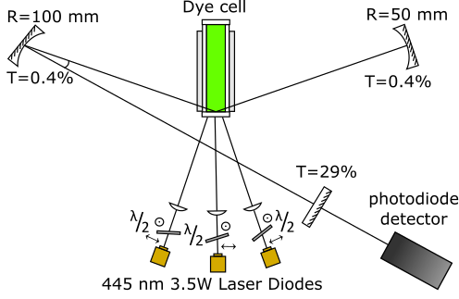
Fig.1. Experimental scheme of a dye laser with semiconductor pumping

Please save your MS Word document as an rtf-file and submit it by e-mail to mppt@mephi.ru; the object of your message should be “MPPT2020” + “Thesis_IvanovII”.
Reference
[1] A. Author, B. Author, C. Author, Title of paper, Journal Name, vol., pp. start-end, (year).

